Experiment 28: Find the Boundary of the Image using Convolution Kernel
Software / Tools: Python · OpenCV (cv2) · NumPy

AIM
To extract the boundary (outline) of objects in an image by convolving it with a boundary-detection kernel.
ALGORITHM
1. Import OpenCV and NumPy.
2. Read the input image and convert it to grayscale.
3. Define a boundary-detection kernel [[-1,-1,-1],[-1,8,-1],[-1,-1,-1]] (sums to zero, so flat regions become 0 and edges are highlighted).
4. Apply cv2.filter2D() with this kernel on the grayscale image.
5. Display and save the boundary image.
PROGRAM (SOURCE CODE)
import cv2
import numpy as np

img = cv2.imread("image.jpg")
gray = cv2.cvtColor(img, cv2.COLOR_BGR2GRAY)

kernel = np.array([[-1, -1, -1],
[-1, 8, -1],
[-1, -1, -1]])

boundary = cv2.filter2D(gray, -1, kernel)

cv2.imshow("Boundary Detected", boundary)
cv2.waitKey(0)
cv2.destroyAllWindows()

OUTPUT
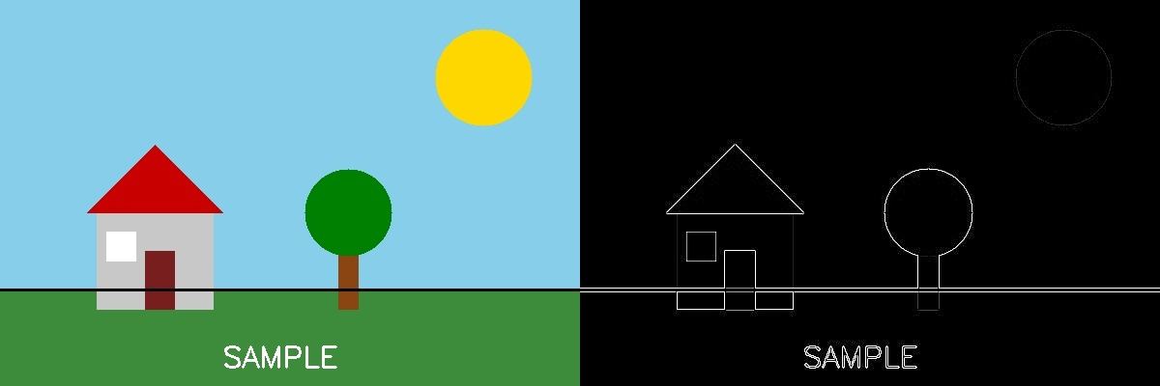
Fig. 28 — Output of Experiment 28: Find the Boundary of the Image using Convolution Kernel.
RESULT
Extract the boundary (outline) of objects in an image by convolving it with a boundary-detection kernel — completed successfully, as demonstrated in the output shown above.

